**Dynamically changing the properties**

**By the end of this tutotial you will come to know:**

* Dynamically accessing the values from the Input field
* Changing the UI element properties Dynamically

**Displaying the Alert message with the name entered in the Input field:**

1. **Open the View and add the "id" for Input tag as below**

<Input id=*"idname"* type=*"Password"* maxLength=*"10"* width=*"300px"* ></Input>

1. **Open the controller and paste the below code in the "onClick" method as below**

onClick: **function**()

{

**var** name= **this**.getView().byId("idname").getValue();

alert("Welcome Mr."+name+" to SAP UI5");

}

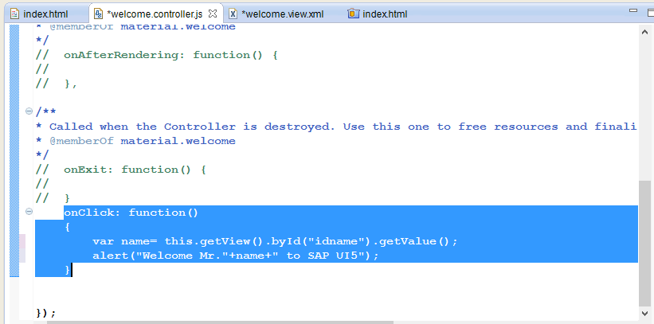

1. **Save all and refresh the browser. Enter your name and click on the Button .You will the below out put**

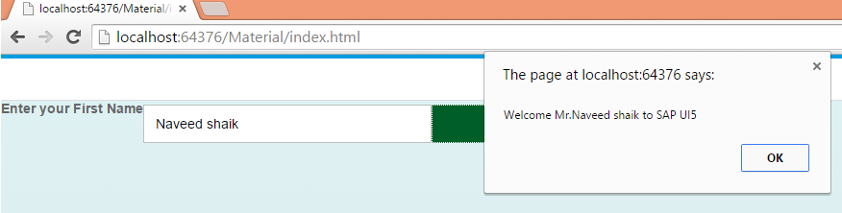

1. **Now let's disable the Input field after clicking the Submit Button**

**Add the below line of code in the " onClick" method as below**

onClick: **function**()

{

**var** name= **this**.getView().byId("idname").getValue();

alert("Welcome Mr."+name+" to SAP UI5");

**this.getView().byId("idname").setEnabled(false);**

}

save all and refresh the browser. In the output , Click on the Button , you will get the alert message . click ok on the alert message then you will find that Input field got diabled.

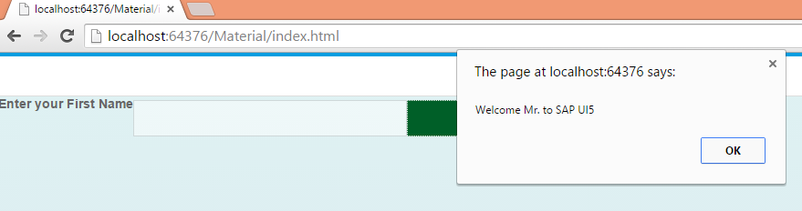

Oberserve the Input field got disabled

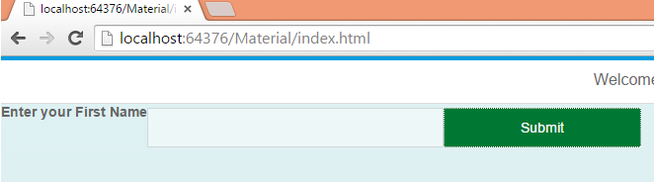

**Hiding and Un Hiding the Lable and Input field :**

1. **Open the view and change as per the below code**

<Label id=*"idlblname"* design=*"Bold"* required=*"false"* text=*"Enter your First Name"*></Label>

<Input id=*"idname"* type=*"Text"* width=*"300px"* ></Input>

<Button id=*"idbtn"* text=*"Hide"* type=*"Accept"* width=*"200px"* press=*"onClick"*></Button>

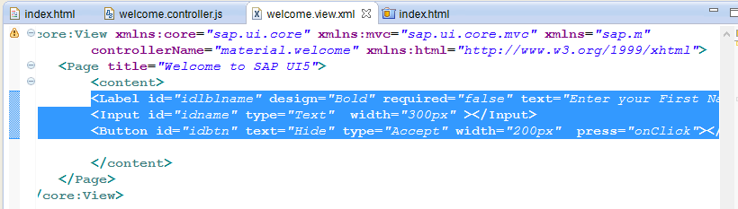

1. **Now Open the Controller and paste the below code**

onClick: **function**()

{

**var** txtOnBtn = **this**.getView().byId("idbtn").getText();

**if**(txtOnBtn=="Hide")

{

**this**.getView().byId("idlblname").setVisible(**false**);

**this**.getView().byId("idname").setVisible(**false**);

**this**.getView().byId("idbtn").setText("UnHide");

}

**else**

{

**this**.getView().byId("idlblname").setVisible(**true**);

**this**.getView().byId("idname").setVisible(**true**);

**this**.getView().byId("idbtn").setText("Hide");

}

}

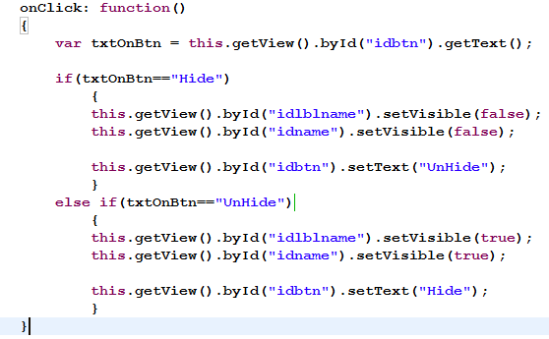

save all and refresh the browser. Click on Hide Button then label and Input field will be hidden and text on the button is changed to UnHide . Now click again then label and input field will be

visible as below

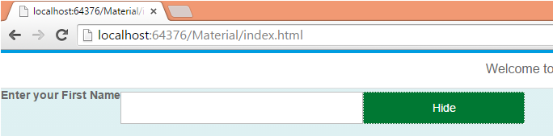

click on Hide you see the below output

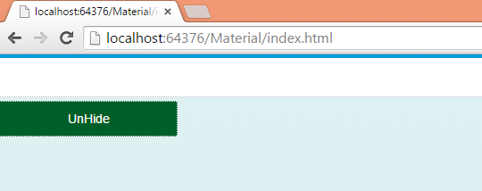

Again Click on UnHide

